Use Wireshark to View Network Traffic Topology

LAB # 04



Spring 2024
CSE-303L Data Communication & Networks Lab

Submitted by: Ali Asghar
Registration No.: 21PWCSE2059
Class Section: C

“On my honor, as student of University of Engineering and Technology, I have neither given nor received unauthorized assistance on this academic work.”

Submitted to:
Dr. Yasir Saleem Afridi

Date:
27th March 2024

Department of Computer Systems Engineering
University of Engineering and Technology, Peshawar
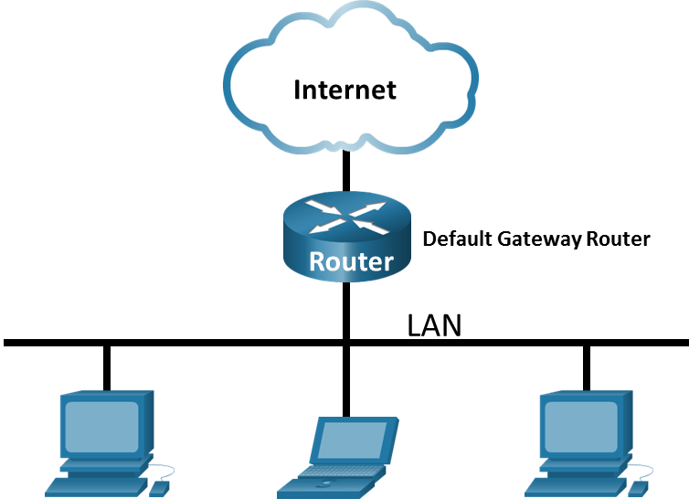

- Objectives
Part 1: Capture and Analyze Local ICMP Data in Wireshark
Part 2: Capture and Analyze Remote ICMP Data in Wireshark

- Background / Scenario
Wireshark is a software protocol analyzer, or "packet sniffer" application, used for network troubleshooting, analysis, software and protocol development, and education. As data streams travel back and forth over the network, the sniffer "captures" each protocol data unit (PDU) and can decode and analyze its content according to the appropriate RFC or other specifications.
Wireshark is a useful tool for anyone working with networks and can be used with most labs for data analysis and troubleshooting. In this lab, you will use Wireshark to capture ICMP data packet IP addresses and MAC addresses.

- Required Resources
- 1 PC (Windows with internet access)
- Additional PCs on a local-area network (LAN) will be used to reply to ping requests.

  - Capture and Analyze Local ICMP Data in Wireshark
Questions:
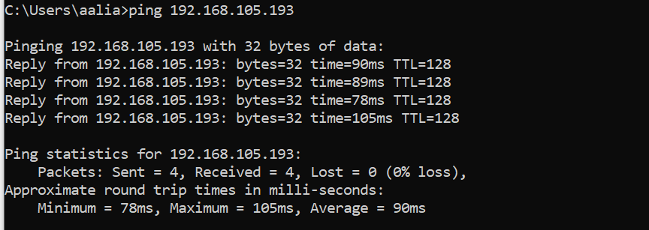
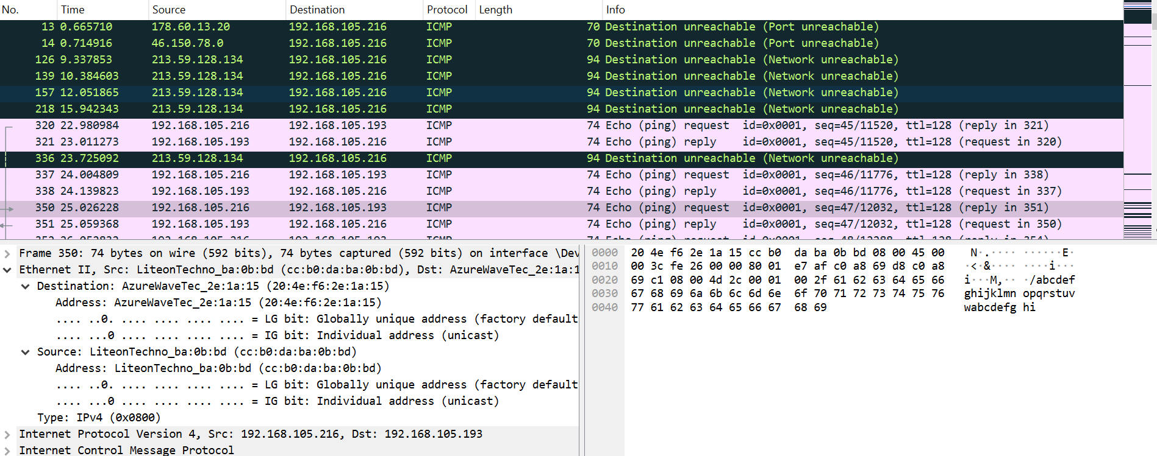

Does the source MAC address match your PC interface?
Ans: Yes
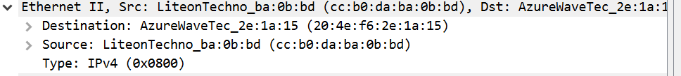
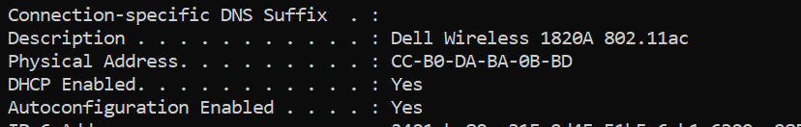

Does the destination MAC address in Wireshark match your team member MAC address?
Ans: Yes. It is 20:4e:f6:2e:1a:15 (team member’s MAC address).

How is the MAC address of the pinged PC obtained by your PC?
Ans: The ping command does not directly obtain the MAC address of the target device. However, once the ICMP echo request reaches the local network, the Address Resolution Protocol (ARP) is used to obtain the MAC address associated with the IP address. The ARP protocol broadcasts a request for the MAC address associated with the IP address being pinged, and the device with that IP address responds with its MAC address. This allows the ping command to send packets to the correct MAC address for the target device.

  - Capture and Analyze Remote ICMP Data in Wireshark
List the destination IP and MAC addresses for all three locations in the space provided.
IP address for www.yahoo.com:
Ans: 69.147.88.8
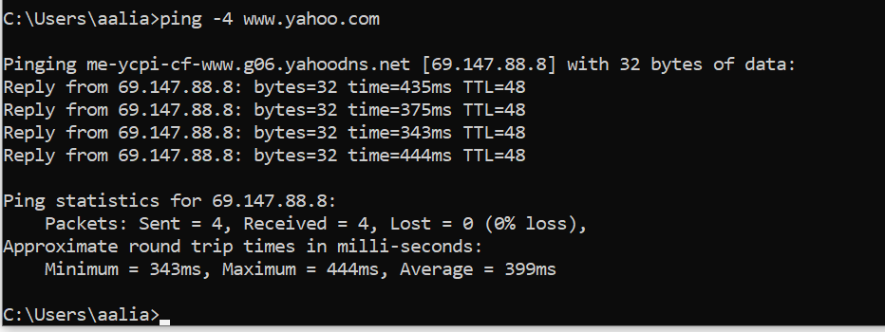
MAC address for www.yahoo.com:
Ans: 7a:b3:56:d0:a3:ad(MAC Address of Router)
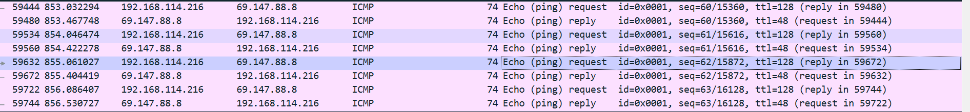
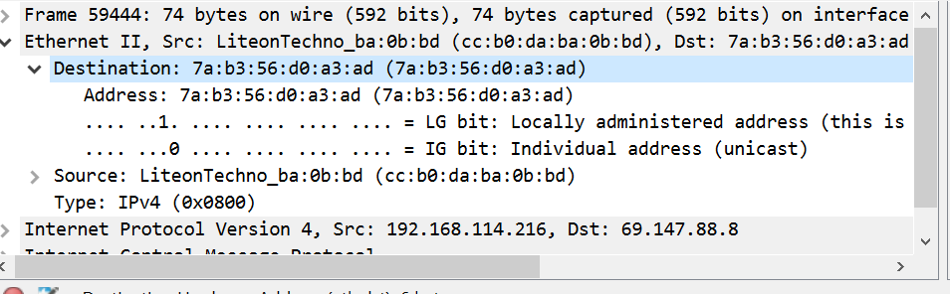
IP address for www.cisco.com:
Ans: 23.52.114.126
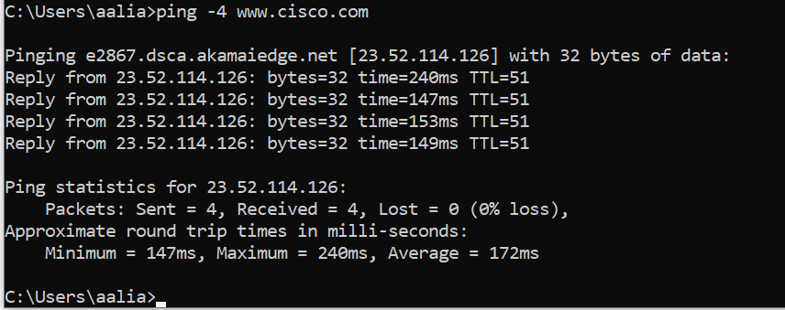

MAC address for www.cisco.com:
Ans: 7a:b3:56:d0:a3:ad(MAC Address of Router)
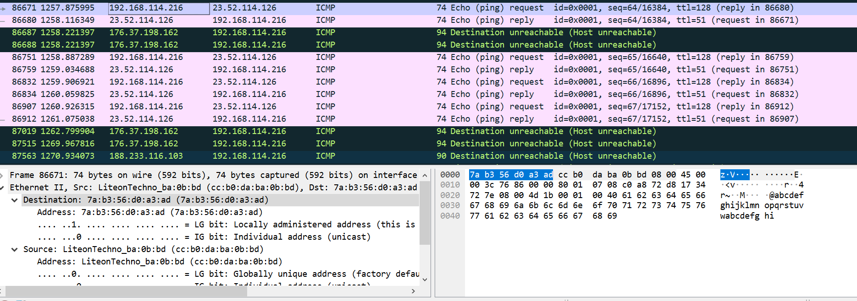

IP address for www.google.com:
Ans: 172.217.17.36
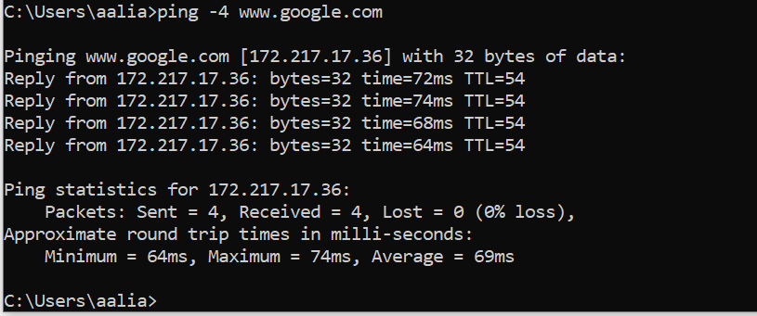

MAC address for www.google.com:
Ans: 7a:b3:56:d0:a3:ad(MAC Address of Router)
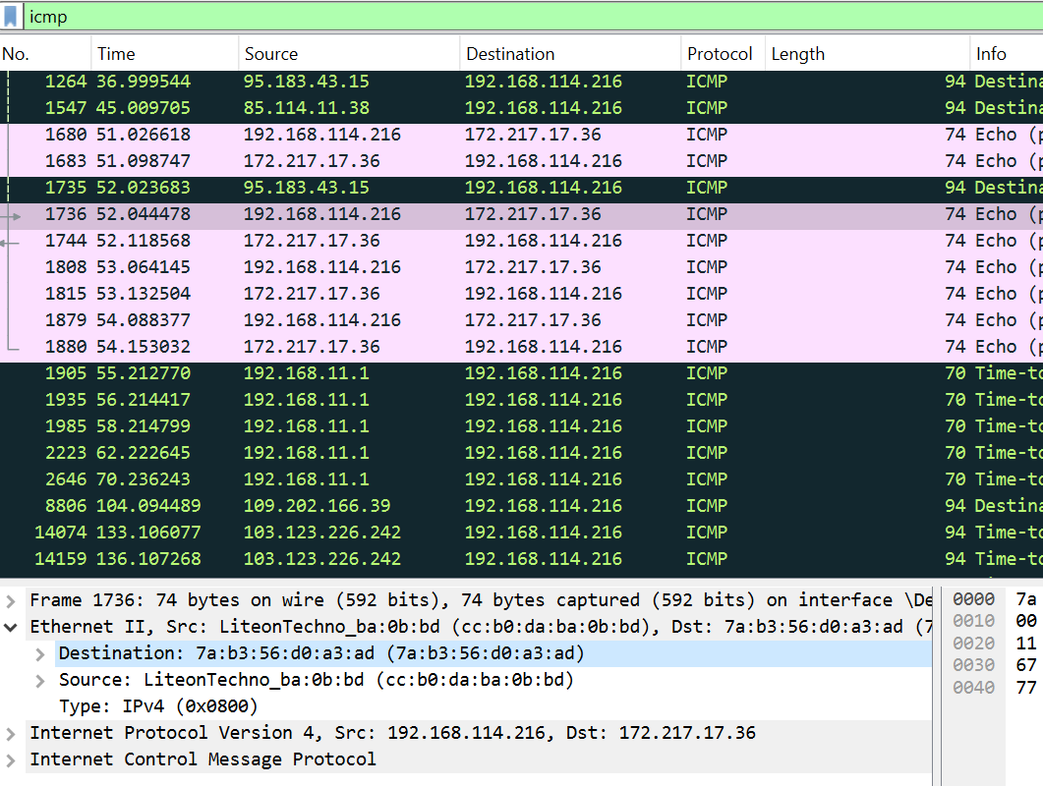

What is significant about this information?
Ans: The MAC addresses for all three locations are the same.

How does this information differ from the local ping information you received in Part 1?
Ans: A ping to a local host returns the MAC address of the PC NIC. A ping to a remote host returns the MAC address of the default gateway LAN interface.

Why does Wireshark show the actual MAC address of the local hosts, but not the actual MAC address for the remote hosts?
Ans: MAC addresses for remote hosts are not known on the local network, so the MAC address of the default-gateway is used. After the packet reaches the default-gateway router, the Layer 2 information is stripped from the packet and a new Layer 2 header is attached with the destination MAC address of the next hop router.

